

FURTHER MATHEMATICS
TRIAL EXAMINATION 1
2012
SOLUTIONS

Section A – answers Section B – answers

Core Module 1 Module 2 Module 3 Module 4 Module 5 Module 6
Number Geometry Graphs Business Networks Matrices
Patterns & & related &
Trig Relations Maths Decision

Maths
1. B 1. A 1. D 1. E 1. B 1. D 1. C
2. C 2. A 2. C 2. C 2. C 2. C 2. D
3. D 3. E 3. A 3. A 3. A 3. E 3. B
4. E 4. B 4. C 4. D 4. A 4. B 4. A
5. A 5. D 5. B 5. B 5. D 5. A 5. E
6. E 6. D 6. C 6. D 6. A 6. D 6. E
7. A 7. E 7. A 7. D 7. C 7. E 7. A
8. D 8. C 8. B 8. C 8. C 8. B 8. D
9. C 9. D 9. D 9. C 9. E 9. D 9. E
10. D
11. C
12. D
13. B

Core: Data analysis

Question 1

The shape of the distribution is best described as negatively skewed.
The answer is B.

Question 2

Method 1

0 | 8
1 | 2
1 | 5
2 | 1 | 2 | 3 | 4
2 | 5 | 5 | 6 | 6 | 7 | 8
3 | 0 | 0 | 0 | 0 | 0 | 0

There are 19 results. The middle score or the median, is the 10th score and that is 26.
There are 9 scores below this and the middle of these scores is the 5th score which is 22.
So 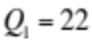
There are 9 scores above the median and the middle of these scores is 30.
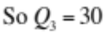.
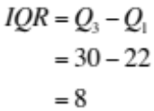
The answer is C.

Method 2 – using a calculator

Enter the data.
Calculate the one-variable statistics.
The answer is C.

Question 3

Enter the data into a calculator.
Calculate one-variable statistics.
(to 1 decimal place).
The answer is D.

Question 4

We know that 99.7% of the weights
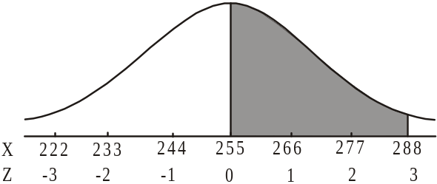
lie between 3 standard deviations
either side of the mean; i.e. between
.
So 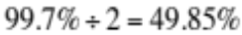 of the weights
will lie in half that region,
i.e. between 255g and 288g.
The answer is E.

Question 5

Using the formula,
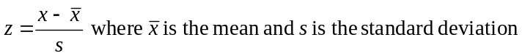
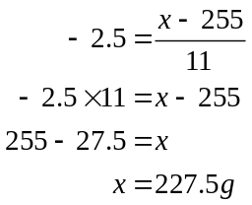
The actual weight is 227.5g.
The answer is A.

Question 6

For the data value of the child who is just over 3, the residual is approximately 0.2.
This eliminates options A and C because they have a residual of approximately 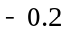. It also eliminates option B where the residual is 1. Options D and E are left. They are the same up until the child who is approximately 5.6 years of age. The residual for that child is approximately 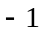. Option E shows this and option D doesn’t.
The answer is E.

Question 7

By inspection of the scatterplot, there is a strong, negative, linear relationship between the variables sleeping time and age. The only value of r that reflects this is -0.90.
The answer is A.

Question 8

Since the correlation coefficient r, is equal to 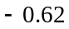, there is moderate, negative correlation between late night hours spent studying and concentration levels. As late night hours spent studying (the independent variable) increases, concentration levels (the dependent variable) decreases because the association is negative. Another way of saying this is that there is some association between late night hours spent studying and decreased concentration levels.
Note that it cannot be claimed that less late night hours spent studying causes an increase in concentration levels. More work would need to be done to claim this.
The answer is D.

Question 9

Enter the data for x and y and then generate the data for the reciprocal of y; that is, .
Find the least square regression line equation for the variables x and .
That equation is 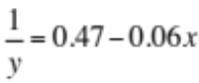 where the coefficients are expressed correct to 2 decimal places.
The answer is C.

Question 10

The retail sales peak in the summer months and trough in the winter months thus showing seasonal variation. (Note cyclic variation could show peaks and troughs also but over a period greater than a year.)
The data overall has a decreasing trend.
The answer is D.

Question 11

To find a four-point moving mean with centring for 2005, we look at the two years either side of 2005.
Year | 2003 | 2004 | 2005 | 2006 | 2007
Number | 452 | 489 | 431 | 492 | 512

Take the four-point mean for the years 2003 – 2006.

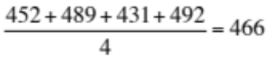
Take the four-point mean for the years 2004-2007.
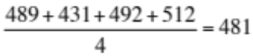
Centring these two four-point means gives us 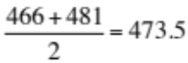
The answer is C.

Question 12

Method 1 – intuitively
The retail sales at this department store in Spring have a seasonal index of 1.25. To get to the quarterly average of 1, they need to be reduced by 0.25 which represents a percentage decrease of
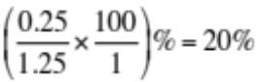.
The answer is D.

Method 2 – using a formula
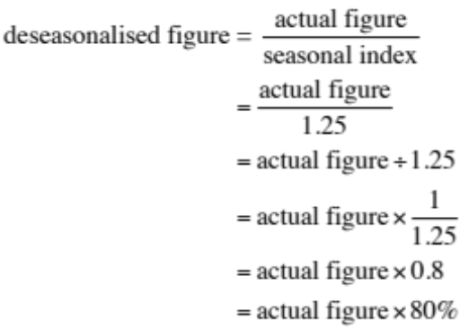
This represents a reduction of the actual figure by 20%.
The answer is D.

Question 13
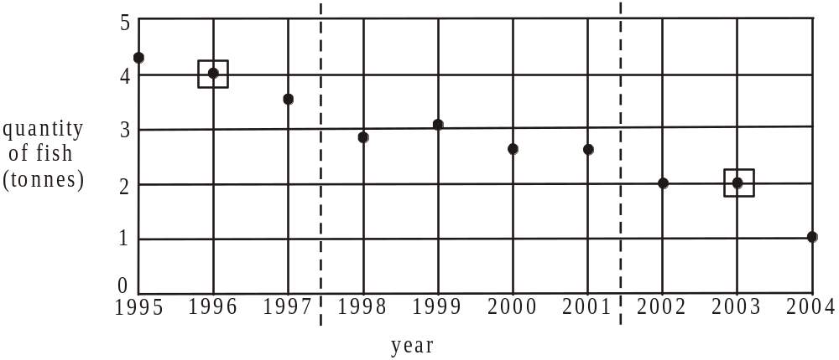

The two outside medians occur at (1996,4) and (2003,2).
The quantity of fish drops by 2 tonnes over a period of 7 years. The gradient of the line is therefore 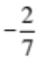. So the average decrease, in tonnes, in the quantity of fish caught is closest to 0.29.
The answer is B.

SECTION B

Module 1: Number patterns

Question 1

For the geometric sequence 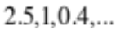 the common ratio 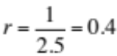 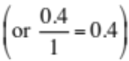.
The answer is A.

Question 2

Terms 1 and 2 are added to give term 3 (i.e. 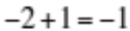).
Terms 2 and 3 are added to give term 4 (i.e.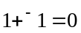) and so on.
Terms 5 and 6 are added therefore to give term 7 (ie. 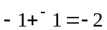).
The answer is A.

Question 3

Method 1

The sequence 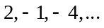 is an arithmetic sequence with 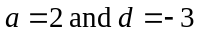.
So 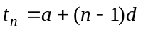 (formula sheet)
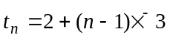
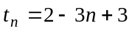
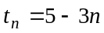
The answer is E.

Method 2

For option A, 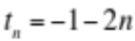
So for the first term 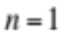, 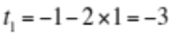.

For option B, 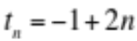
So for the first term , 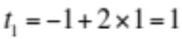.

For option C, 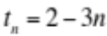
So for the first term , 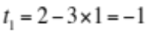.

For option D, 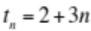
So for the first term , 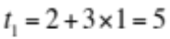.

For option E, 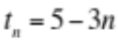
So for the first term , 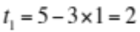.

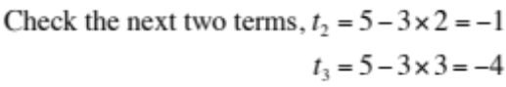
The answer is E.

Question 4

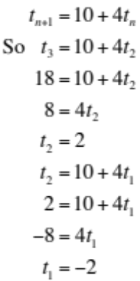
The answer is B.

Question 5

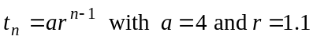
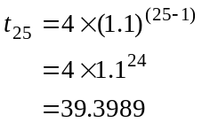
The closest answer is 39.4.
The answer is D.

Question 6

Since, the sequence is not arithmetic.
Since 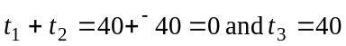 the sequence is not a Fibonacci related sequence.
Since 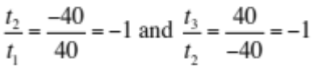 and so on, the sequence is geometric with 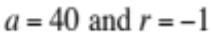.
The answer is D.

Question 7

The sequence 160,120,90,… is a geometric sequence with 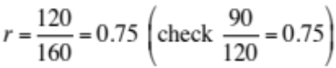.
Since 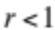 we can use the sum to infinity formula
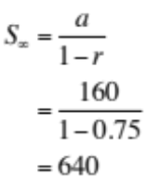
(formula sheet)
The answer is E.

Question 8

The number of stamps in the nth year is 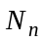, so the number of stamps in the next year is 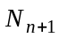.
Therefore 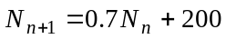 that is, the number of stamps in the next year is equal to 0.7 (or 70%) of the stamps in the previous year since 0.3 (or 30%) have been donated to others and 200 stamps have been added to the collection.
The answer is C.

Question 9

The lengths 5, 8, 11, 14, … form an arithmetic sequence with 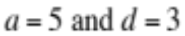.
For an arithmetic sequence,
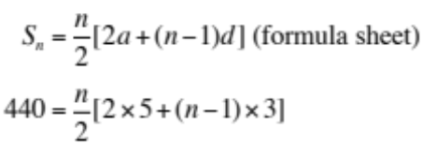
Solve this for n using CAS
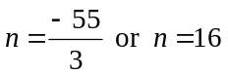
We are looking for a term number so reject 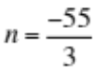.
The 16th term is the last term of the series. Since it is an even number the knitted section will be white.

Method 1
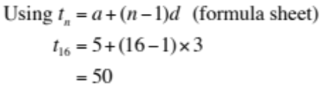
The last section Regina knits is white and 50cm long.
The answer is D.

Method 2
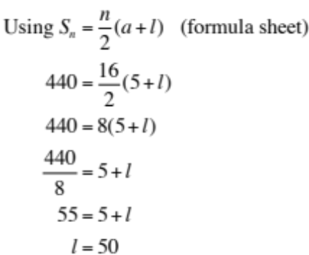
The last section Regina knits is white and 50cm long.
The answer is D.
Module 2: Geometry and trigonometry

Question 1
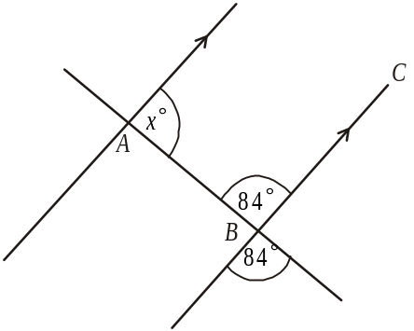

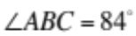 (vertically opposite angles)
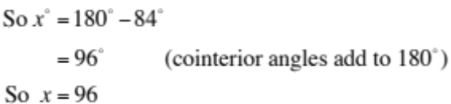
The answer is D.

Question 2

Heron’s formula, which calculates the area of a triangle, is given by
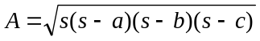 (given on formula sheet)
where a, b and c are the 3 side lengths of the triangle and
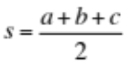
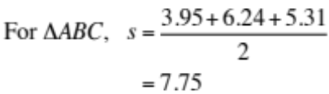
The answer is C.

Question 3

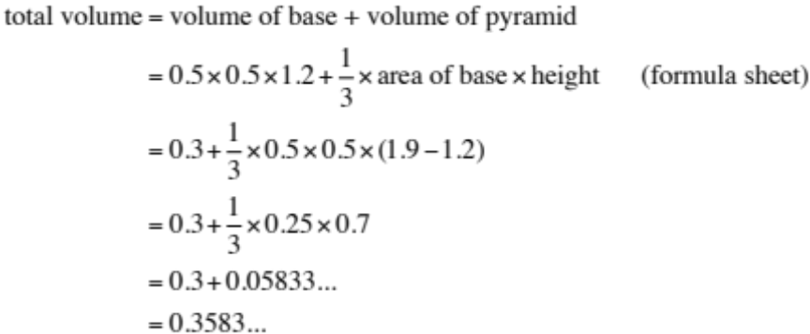
The closest answer is 0.36.
The answer is A.

Question 4
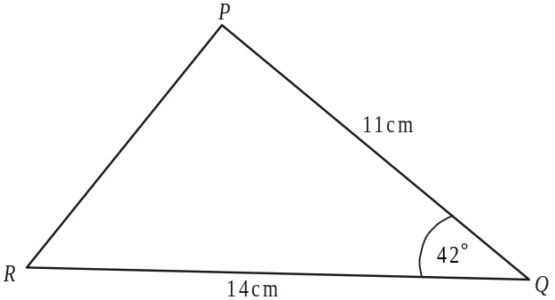

Using the cosine rule, (because we have 2 sidelengths and the included angle)
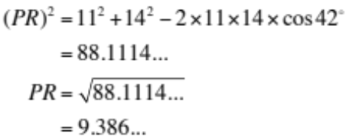
The closest answer given is 9.4.
The answer is C.

Question 5

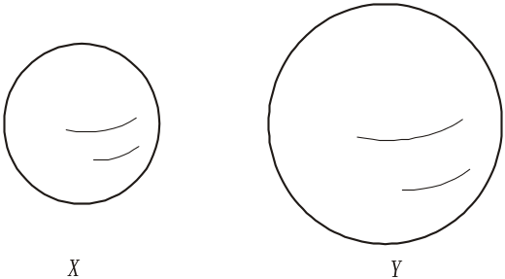

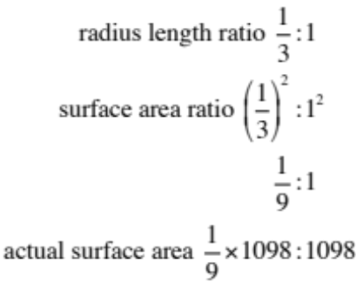
Surface area of sphere X is 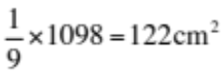
The answer is B.

Question 6

Draw a diagram.

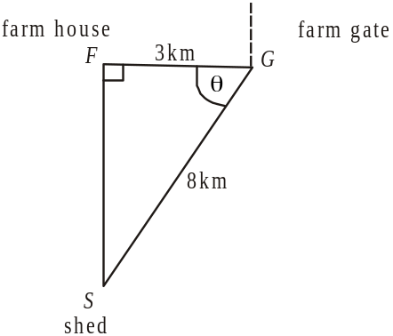

Since the farmer’s last drive is due north, the shed must be due south of the farm house.
Also, from the diagram, 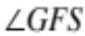 is a right angle since the gate is due east of the farm house.
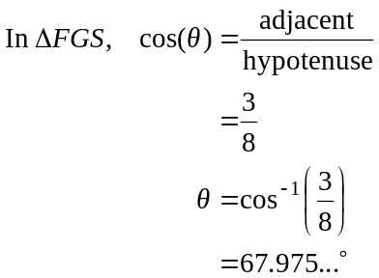
So the bearing of the shed from the gate is
The closest answer given is 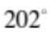.
The answer is C.

Question 7

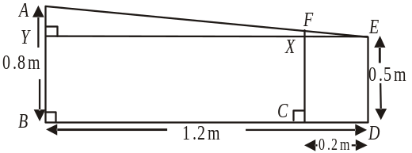
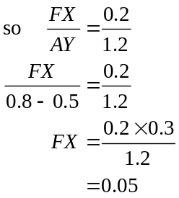
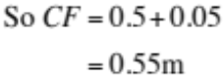
The answer is A.

Question 8

In 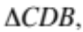
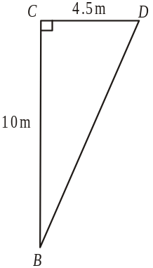
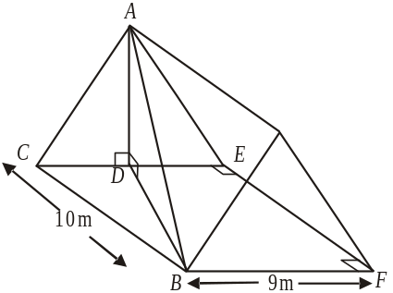
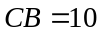
and 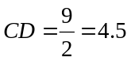
because 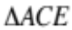
is an isosceles triangle
(i.e. 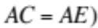
Using Pythagoras,
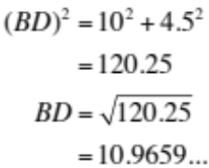
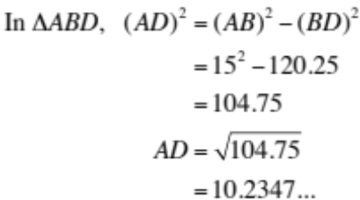
The closest answer given is 10.23.
The answer is B.

Question 9
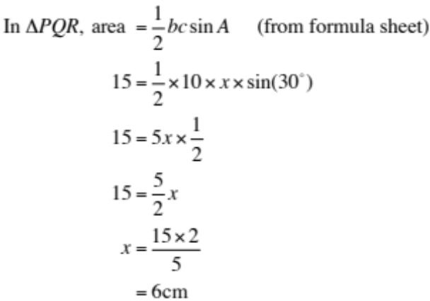

In 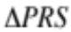,
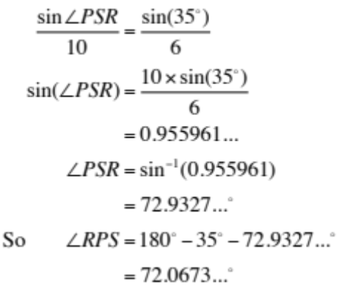
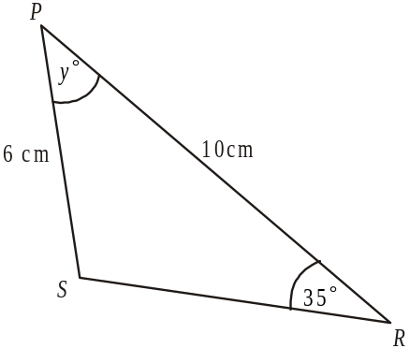
The closest answer given is 72°.
The answer is D.

Module 3: Graphs and relations

Question 1

From the graph, the saturated oxygen level is less than 65% from nearly the end of week 3 until the end of week 5 which is just a little over 2 weeks and then again from the end of week 7 until the end of week 12 which is 5 weeks. In total the level is less than 65% for just over a total of 7 weeks. The only answer that describes this is “approximately 7 weeks”.
The answer is E.

Question 2

The average rate of increase is given by the average gradient of the line between week 4 and week 6.
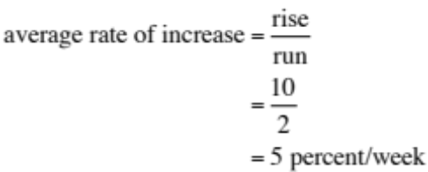
The answer is C.

Question 3

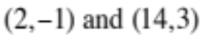
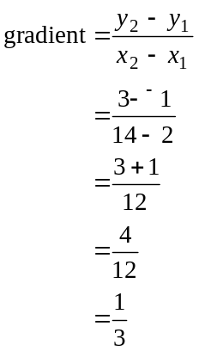
The equation of a straight line with gradient m and passing through the point 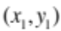 is given by 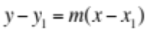
Using 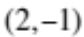 (you can use either point)
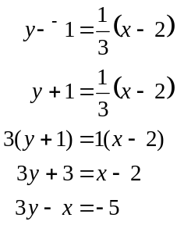
The answer is A.

Question 4

If Annie’s costs are given by C, then 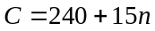 where n is the number of bags sold.
Let 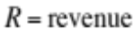

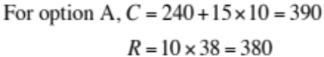
Annie makes a loss.

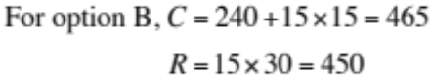
Annie makes a loss.

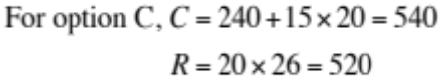
Annie makes a loss.

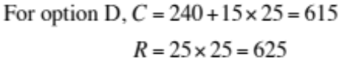
Annie makes a profit.
The answer is D.

Question 5

The amount Liv earns in a month from day shifts is 200x. The amount she earns in a month from night shifts is 320y.
In a month her total earnings must be at least $4 800.
So, 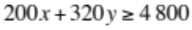
The answer is B.

Question 6

Break-even occurs at the point where the cost line intersects with the revenue line. This occurs at the point 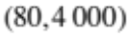.
This represents 80 items being sold and the cost and the revenue are both $4 000. Option D is not true.
The answer is D.

Question 7

The graph shows a linear relationship between 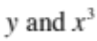. The equation is of the form 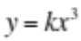.
Since, from the graph, 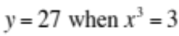, we have
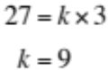
The required equation is therefore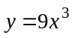.
The answer is D.

Question 8

A pair of simultaneous equations will have no solution if the left hand side of the equations (containing the x and y terms) are identical and the right hand sides are different.
Option A and B cannot have the left hand sides identical because of the positive and negative signs.
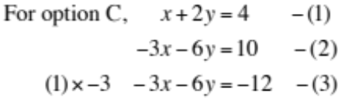
Equations (2) and (3) have identical left hand sides and different right hand sides. This means their graphs will be parallel lines and so there will be no point of intersection and hence the equations will have no solution.
The answer is C.

Question 9

The equation of the line with x-intercept of 100 and y-intercept of 100 is 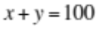.
It intersects the line with equation 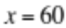 at the point T which has coordinates 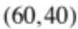.
So, the corner points of the feasible region are .

For 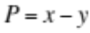,
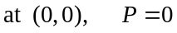
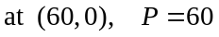
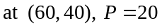
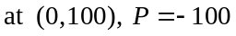
The maximum does not occur at T.

For 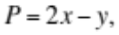
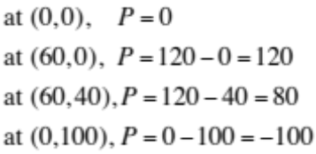
The maximum does not occur at T.

For 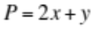,
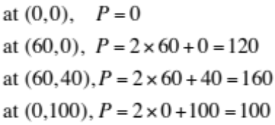
The maximum occurs at T.
The answer is C.
Module 4: Business-related mathematics

Question 1

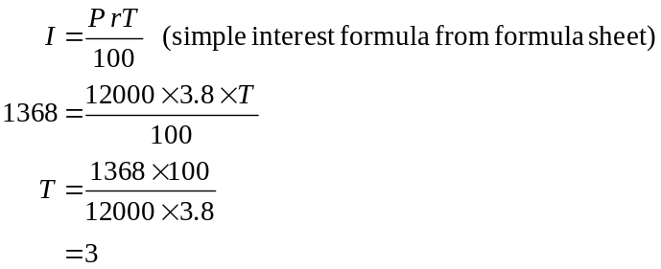
The answer is B.

Question 2

The truck is to be depreciated by 9% of $32 000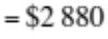annually.
Over 5 years this is 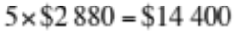.
So after 5 years the truck is valued at 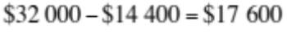.
The answer is C.

Question 3

The minimum balance for the account in June is $1 152.
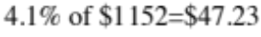 gives us the annual amount of interest at 4.1%.
The monthly interest is 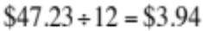.
The answer is A.

Question 4

Using the compound interest formula
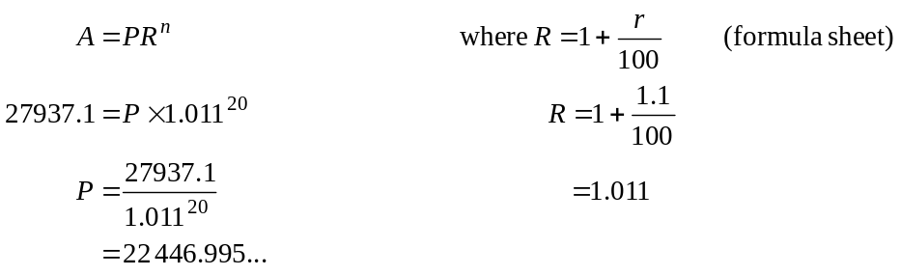
Note that the interest rate per year is 4.4% so per quarter it is 1.1%.
The amount invested must therefore have been $22 447.
The answer is A.

Question 5

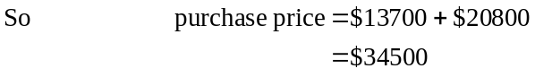
The answer is D.

Question 6

Using TVM

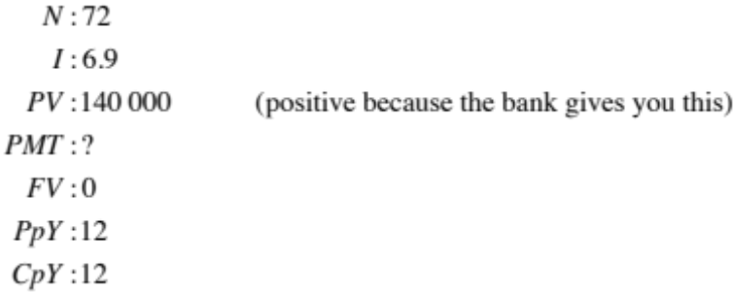
JulIe’s monthly payment will be $2 380.14.
Note that this is expressed as -$2 380.14 on the calculator. This is because Julie has to give this amount to the bank each month.
The answer is A.

Question 7

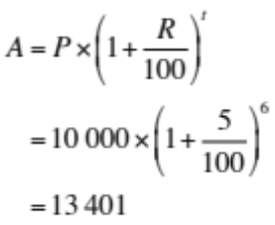
Note that in 1998 Victoria received $10 000. In 1999 she received 10 000 + 5% of $10 000 so in the above formula t would equal 1.
Continuing the pattern, in 2004, t equals 6 and Victoria receives $13 401.
The answer is C.

Question 8

Using TVM

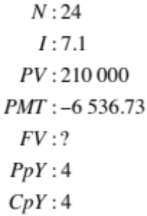
Six years (i.e. 24 quarters) into the loan, the principal still owing is $126 845.17.
The answer is C.

Question 9

Use TVM to find the period of the loan.

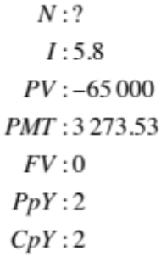
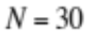
So the annuity lasts for 30 half years or 15 years.

Option A is incorrect.

Option B is incorrect also since the $65 000 plus interest is paid to Ted over the course of the annuity.

Option C is incorrect since over the 15 years Ted receives 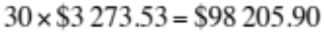.
Of this, 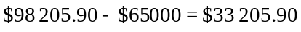 is interest.

Option D

Using TVM again
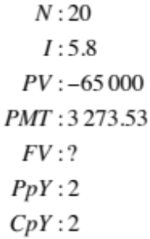
The amount of principle left in the annuity after 10 years is $28 066.89 which is clearly not less than $25 000.

Option E is correct since from our work for Option C we saw that over the 15 years that the annuity runs for, Ted receives .
The answer is E.

Module 5: Networks and decision mathematics

Question 1

The graph is planar because the graph can be redrawn so that no two edges meet.
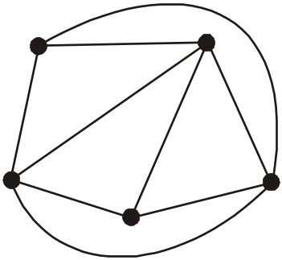

The graph is simple because there are no loops or multiple edges.
The graph is connected because there is a path (not a single edge necessarily) between each pair of vertices.
The graph is NOT complete because there is not an edge connecting all pairs of vertices.
The graph is clearly undirected (no arrows on the edges).
The answer is D.

Question 2
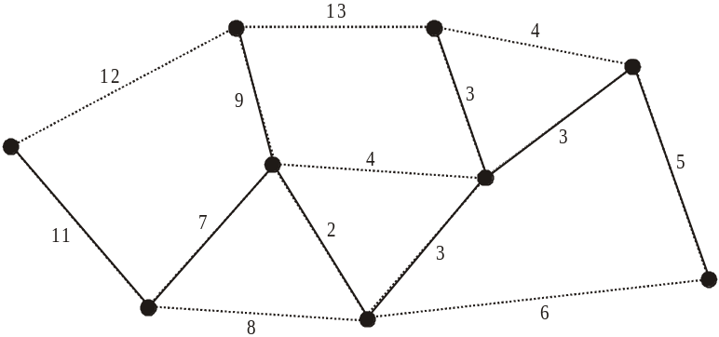

Starting with the edge with weight 2, the lowest weight, construct the minimal spanning tree. Of the weight’s given only 11 is on the minimal spanning tree.
The answer is C.

Question 3

Since the graph is connected and planar, we can use Euler’s formula.
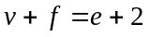 (formula sheet)
Since 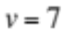,
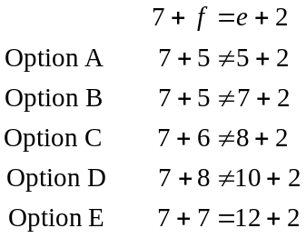
The answer is E.

Question 4

Sarah can do tasks P and S.
So her row in the matrix should have a 1 under P and S and a zero elsewhere.
Maddie can do tasks P and R.
Kate can do tasks R and S.
Nat can do tasks P and Q.
The required matrix is
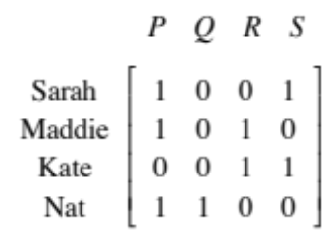
The answer is B.

Question 5

The route taken by the bus is an Euler circuit. For an Euler circuit to exist the degree of each vertex must be even.
Vertices B, C, D, E, G, H and I have even degrees whereas A and F do not. The missing edge is between vertices A and F.
The answer is A.

Question 6

Activity F is an immediate predecessor of I whereas activity C is not.
Activities B and E are also immediate predecessors of activity I because they are connected to it by the dummy activity.
The three immediate predecessors are activities B, E and F.
The answer is D.

Question 7

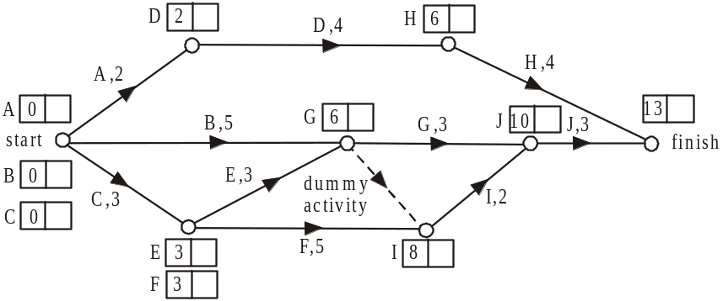

Complete the earliest start times for each of the activities. The minimum time, in weeks in which this project can be completed is 13 weeks.
The answer is E.

Question 8

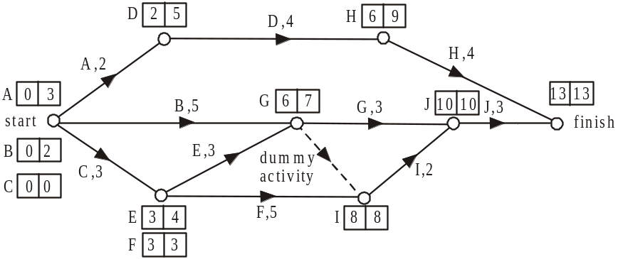

Complete the latest start times for each of the activities. Activities C, F, I and J lie on the critical path. Activities A, D and H have a float time of 3 weeks. Activities E and G have a float time of 1 week. Activity B has a float time of 2 weeks.
The answer is B.

Question 9

20 | 30 | 40 | 35
10 | 15 | 20 | 10
60 | 50 | 65 | 70
40 | 30 | 35 | 45

Step 1 – subtract the minimum entry in each row from each of the other entries in the row

0 | 10 | 20 | 15
0 | 5 | 10 | 0
10 | 0 | 15 | 20
10 | 0 | 5 | 15

Step 2 – since the third column has no zeros, subtract the minimum entry in this column (i.e. 5) from each of the other entries in the column.

0 | 10 | 15 | 15
0 | 5 | 5 | 0
10 | 0 | 10 | 20
10 | 0 | 0 | 15

Step 3 – cover the zero entries with as few lines as possible.

0 | 10 | 15 | 15
0 | 5 | 5 | 0
10 | 0 | 10 | 20
10 | 0 | 0 | 15

The minimum number of lines is 4 so we can create a bipartite graph.

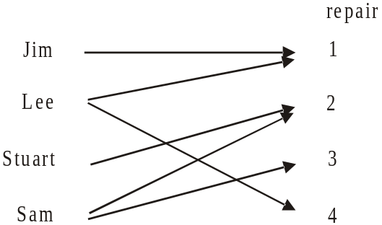

The allocation is
 | Repair
Jim | 1
Lee | 4
Stuart | 2
Sam | 3

The minimum time taken for the technicians to complete the 4 repairs is 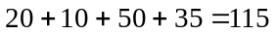 minutes.
The answer is D.
Module 6: Matrices

Question 1

The order of a matrix is the number of rows by the number of columns.
For the matrix 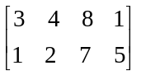, the order is 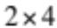 since there are two rows and four columns.

The answer is C.

Question 2

For option A,
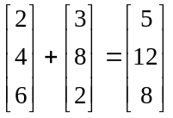
For option B,
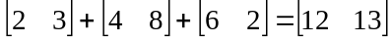
For option C,
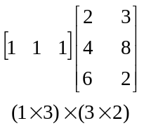
the resulting matrix is of order 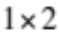.
For option D,
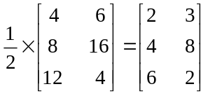
This is correct.
The matrix multiplication in option E is not defined.
The answer is D.

Question 3

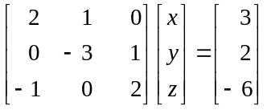
The three simultaneous linear equations are
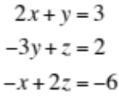
Only the second equation is given.
The answer is B.
Question 4

When a system of simultaneous linear equations is expressed as a matrix equation, the system will not have a unique solution when the determinant of the 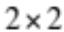 (in this case) matrix is equal to zero.
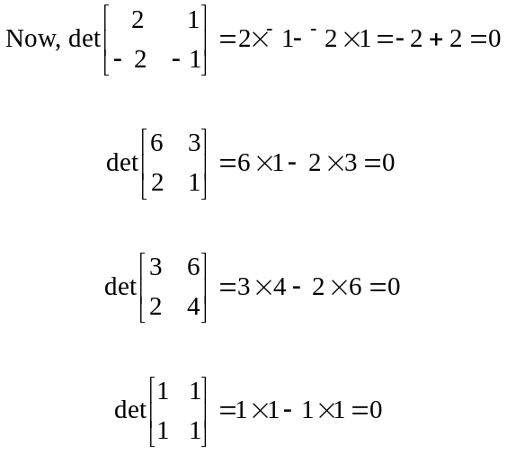
So none of the systems of simultaneous linear equations have a unique solution.
The answer is A.

Question 5

The question asks for the price of the three different sized TV’s for the 3 different brands so the resulting matrix should be 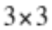.
This eliminates options A.
Also, since brand A is being discounted by 10%, its current price should be multiplied by 0.90 to obtain the discounted price. Similarly for brand B, the current price should be multiplied by 0.75 and for brand C it should be 0.85.
This eliminates options B.
For option C, the resulting matrix will have order 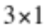.
Since 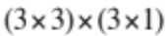 yields an order of .
For option D, the resulting matrix will have order , since 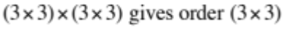).
However, all the 40 inch TV’s will be discounted by 10%, all the 46 inch TV’s will be discounted by 25% and all the 55 inch TV’s will be discounted by 15%.
The answer is E.

Question 6

According to the transition diagram, after one month, customers will have remained with the same energy company.
The answer is E.

Question 7

Using matrices, we have 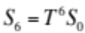 where 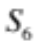 is the state matrix 6 months after the campaign begins. 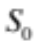 is the initial state matrix and T is the transition matrix which can be derived from the transition diagram.
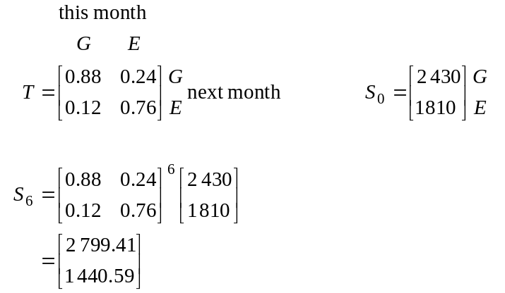

The closest answer is 1 441.
The answer is A.

Question 8

If the matrix product PQ is defined then 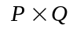
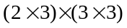
Q must be a matrix because we are told it is square and it must have 3 rows because matrix P has 3 columns and matrix PQ must be defined.
If matrix P has four zero elements, then there can be 1 row that contains only zeros. If this is the case then 3 of the elements in PQ can be zero.
If there are two zeros in each row of P then all of the elements in PQ will be non-zero.
The maximum number is 3.
The answer is D.

Question 9

Method 1
From the transition matrix we see that all the families who elect to receive the newsletter via email this week elect to receive it by email next week. Of those who received it by hard copy this week, 60% elect to receive it by email next week. Over time the number receiving it by hard copy will reach zero and all those who started in week 1 receiving it by hard copy will have gone over to email. This will mean that over the long term, the number receiving it by email will double.
The answer is E.

Method 2
Let n be the number of families receiving the newsletter by email in the first week.
So, the number receiving it by hard copy in the first week is also n.
The state matrix for the first week therefore is 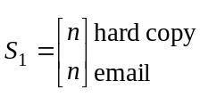

In the tenth week,

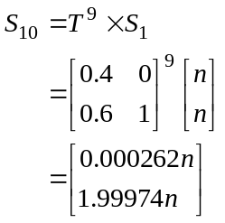

In the eleventh week,

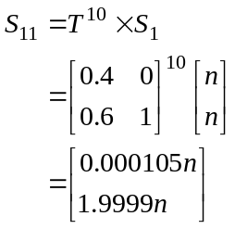
Over the long term we see that the state matrix approaches 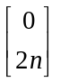.
This will mean that over the long term, the number receiving it by email will double.
The answer is E.

